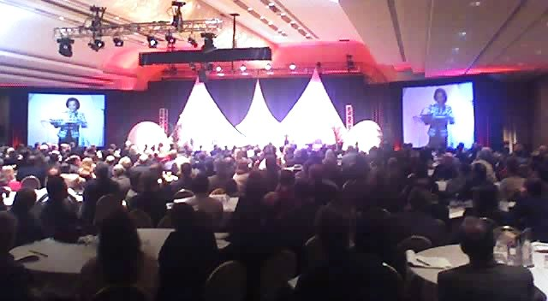
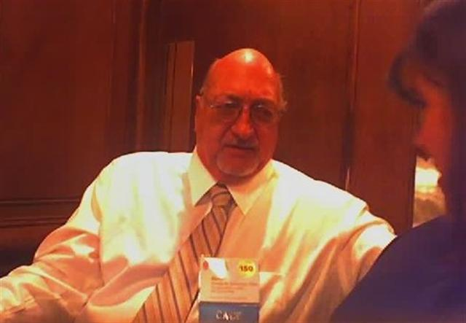
Three members of our Chapter joined over 1000 other AIA leaders from around the country for a nearly weeklong series of presentations, workshops, seminars, and social networking. Matthew Shigihara, Don Comstock, and Mike Malinowski were the first attendees representing AIACV at this event in quite a number of years – in fact our chapter was awarded an AIA National grant to help support our re-engagement with this incredible event!
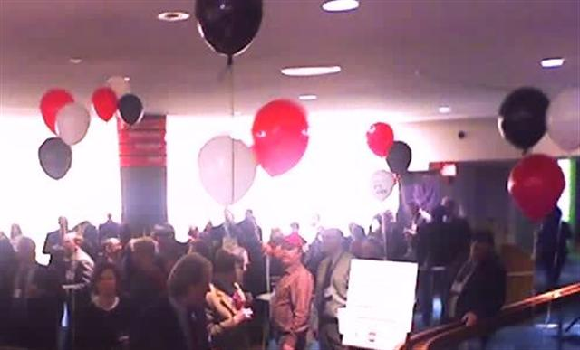
There were dozens of programs: Public Speaking “Where’s the Money”; Using the Web for effective Component Connectivity; Engaging the AIA in the political process proactively, etc … and networking social gatherings including a really great event by AIACC and another by AIA National at the headquarters: …

Not having been to Washington DC before, I took advantage of some of the extra hours before and after the programs to tour many museums and buildings on foot – a very compact and walkable city. As venues are for the most part free it was easy on a brisk walk to dash in for a quick look. Moving fast, I was able to take a peek at about 10 of the 14 museums that make up the ‘Smithsonian’ (I had thought the Smithsonian was a ‘place’ – it’s actually a ‘collection’).

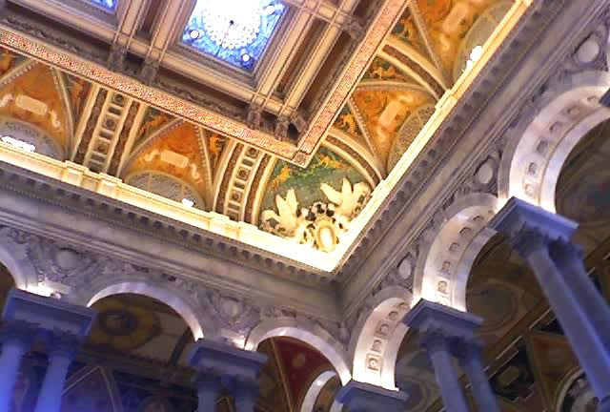
My favorite building – the Library of Congress – which has the most beautiful ceiling art in a romantic, art nouveau style.

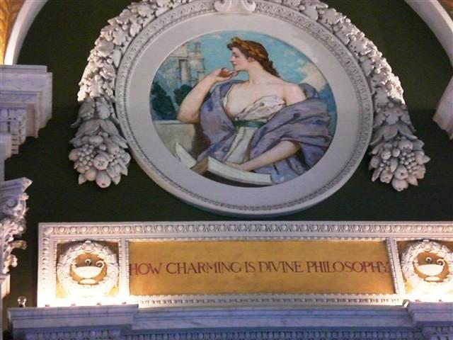

Hope you enjoy a few photos of some of the themes and curiosities of the nation’s capitol
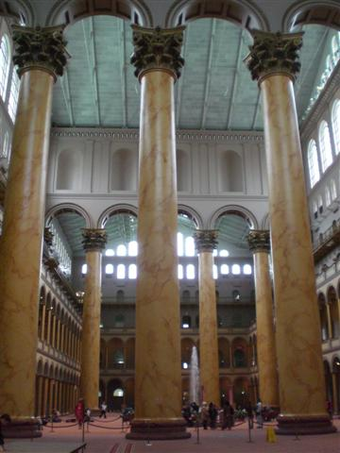
The National Building Museum … check out the scale of these columns … and notice the tiny white specks just below the high ceiling … they are busts of ??? architects ??? … I need to bring binoculars next time …
…

A plethora of Greek and classic temples … can you say “Parthenon” fast a dozen times?…
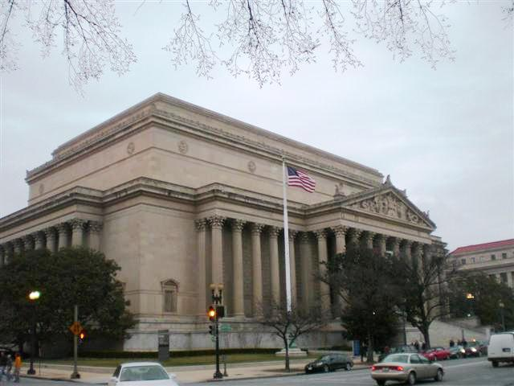
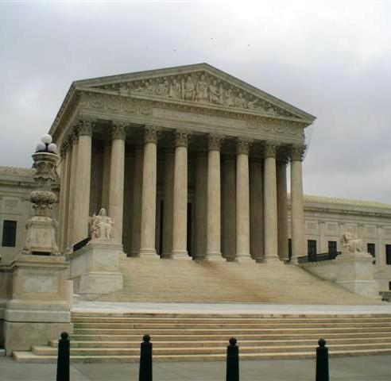

I noticed LOTS of writing on building facades – somehow we’ve lost the boldness to commit to words to that degree … imagine a spelling error in stone!!!

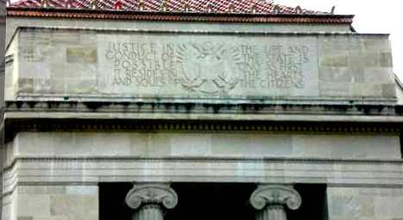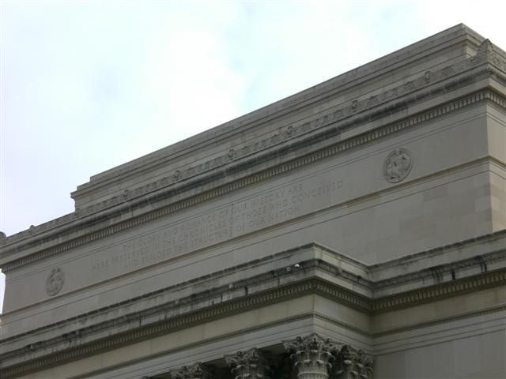

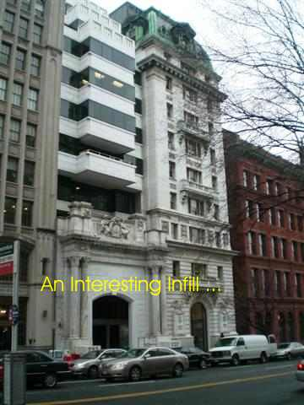
Contrasts and Contradiction in historic preservation … including many examples of a ‘slice of history’ sandwich approach to preservation

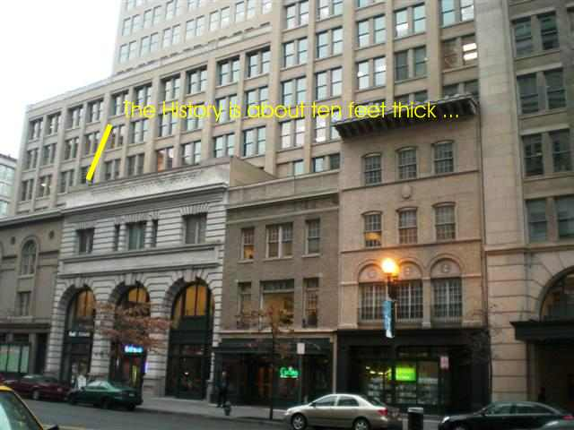

An apparent fascination with the circular form …
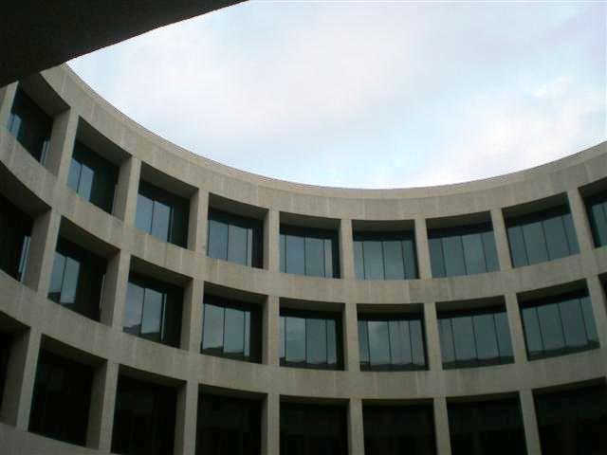
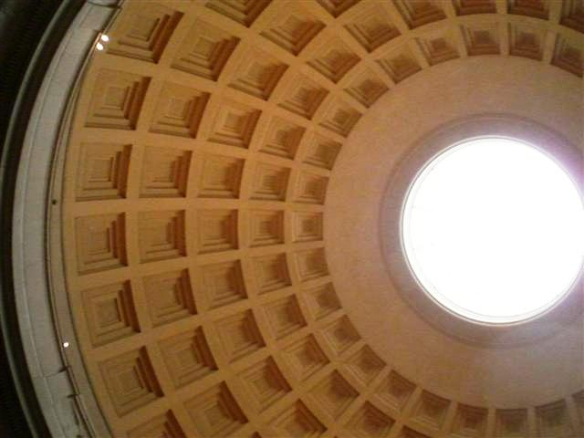
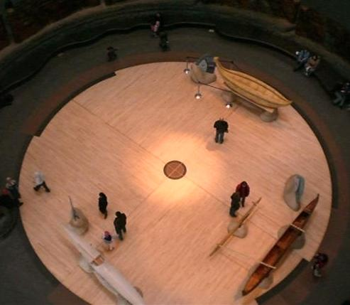

And of course … the usual suspects

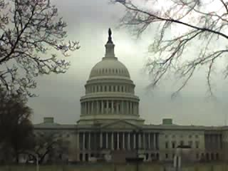
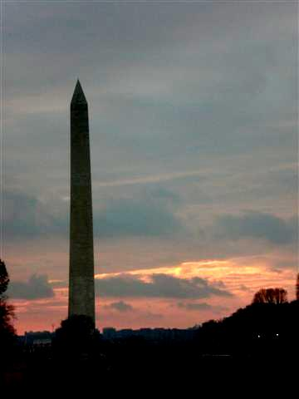
It was an exciting week, of meeting AIA people and seeing some great places … some synergies are already shaping up, such as cross event publicity with AIA East Bay and Sierra Valley chapters … some suggested revisions to the Architect finder to the software authors that may be in the next cycle, and much much more. I hope our chapter is well represented in the future, and in fact I support Matthew’s suggestion that we find a way to establish a ‘scholarship’ for one of our more ‘activated’ AIACV Associate members to go each year …

Thoughts, comments or suggestions? Drop me an email: TUmfm@appliedarts.netUT Mike Malinowski AIA

